Database Design and the Entity-Relationship Model

Data Model : A data model is a collection of conceptual tools for describing data, data relationship, data semantics and consistency constraints.
Entity-Relationship Model: This is a higher-level data model. It is based on a perception of a real world that consists of a collection of basic objects, called entities and the relationship among these objects.
Relational Model: This is a lower level model. It uses a collection of tables to represent both data and relationships among those data.
Designers often formulate database schema design by first modeling data at a high level, using E-R model and then translating it into the relational model.

Entity : An entity is a “thing” or “object” in the real world that is distinguishable from all other objects. An entity has a set of properties and the values for some set of properties may uniquely identify an entity. An entity may be concrete, such as a person or a book, or it may be abstract, such as loan, or a holiday, or a concept. (Example: specific person, company, event, plant)
Entity Set: An entity set is a set of entities of the same type that share the same properties, or attributes.( Example: set of all persons, companies, trees, holidays)
Customer – The set of all persons who are customers at a given bank
Loan – The set of all loans awarded by a particular bank

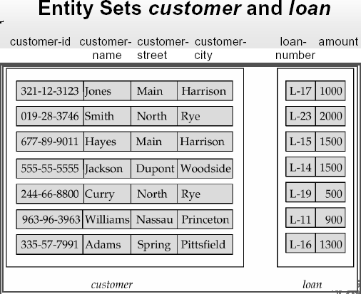

Attributes: An entity is represented by a set of attributes, that is descriptive properties possessed by all members of an entity set.

Domain or value set: For each attribute, there is set of permitted values, called the domain or value set.
Attribute Types:
Simple and Composite
Simple – When an attribute is not possible to divided into subparts, customer city, country
Composite – Composite attributes can be divided into subparts i.e. other attributes. Composite attributes help us to group together the related attributes, making the modeling cleaner.
name – first-name, middle-name, last-name
address – street, city, state, zip-code (postal code)
street – street-number, street-name, apartment-number

Single-valued and multi-valued
Single-valued – when there exist a single value for a particular entity, loan-number
Multi-valued – When there exist a set of values for a specific entity, phone-number, dependent-name of the employee entity set
Boundary can be assigned for a multi-valued attribute

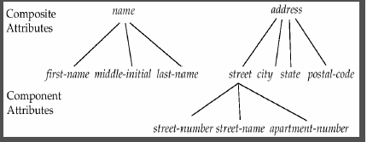

Derived attributes:
- Can be computed from other attributes
- Example: age, given date_of_birth
Null Value: An attribute can take a null value when an entity does not have a value for it.
1. Not applicable – middle name
2. Unknown – a. missing – the value does exist but we do not have that information - name
– b. not known – do not know whether or not the value actually exist
Common Example: apartment no.

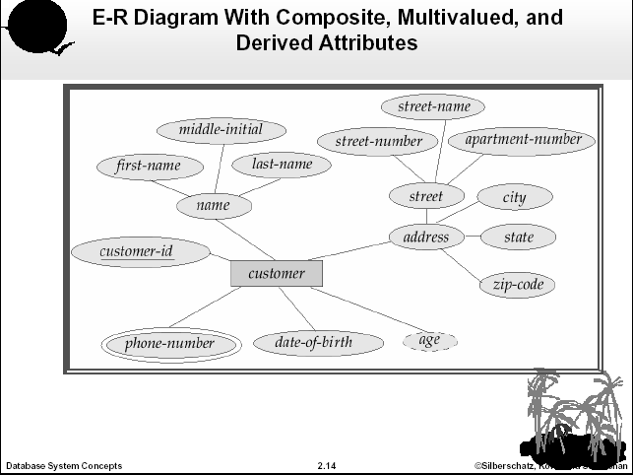

Relationship: A relationship is an association among several entities
Relationship Set: A relationship set is a set of relationships of the same type.

borrower – association between customer and loan
loan-branch – association between loan and branch
depositor – association between customer and account

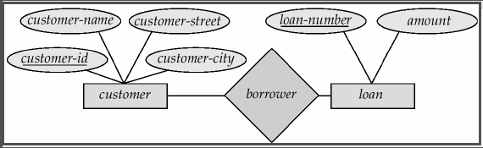

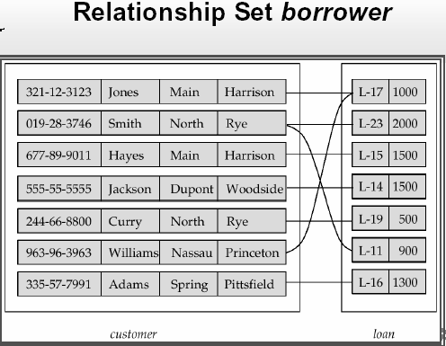

Descriptive Attribute: A relationship may also have attributes called descriptive attributes.
depositor : customer – account, access-date (the most recent date on which a customer accessed an account.

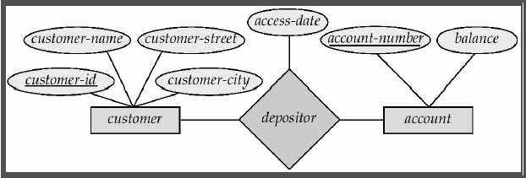

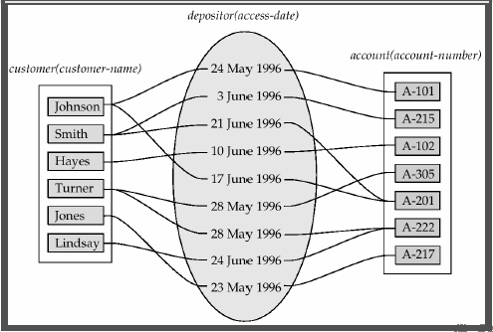

Degree of Relationship set: The number of entity set that participate in the relationship set is called the degree of the relationship set. A binary relationship is of degree 2; a ternary relationship set is of degree 3.

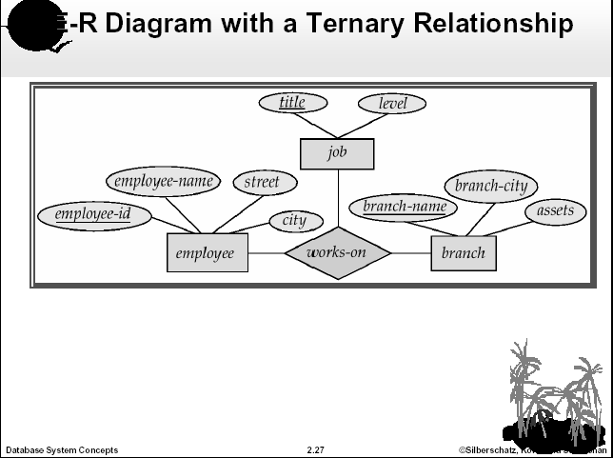

Mapping Cardinality Constraints:
1. One to one
2. One to many
3. Many to one
4. Many to many

One to one – An entity in A is associated with at most one entity in B, and an entity in B is associated with at most one entity in A.
One to many - An entity in A is associated with any number (zero or more) entities in B. An entity in B, however, can be associated with at most one entity in A.

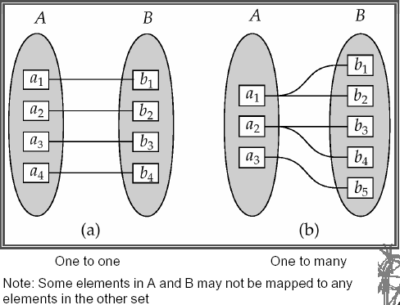

Many to one - An entity in A is associated with at most one entity in B. An entity in B, however, can be associated with any number (zero or more) entities in A.
Many to many - An entity in A is associated with any number (zero or more) entities in B and An entity in B can be associated with any number (zero or more) entities in A.

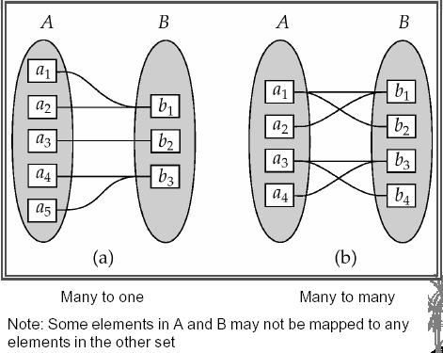

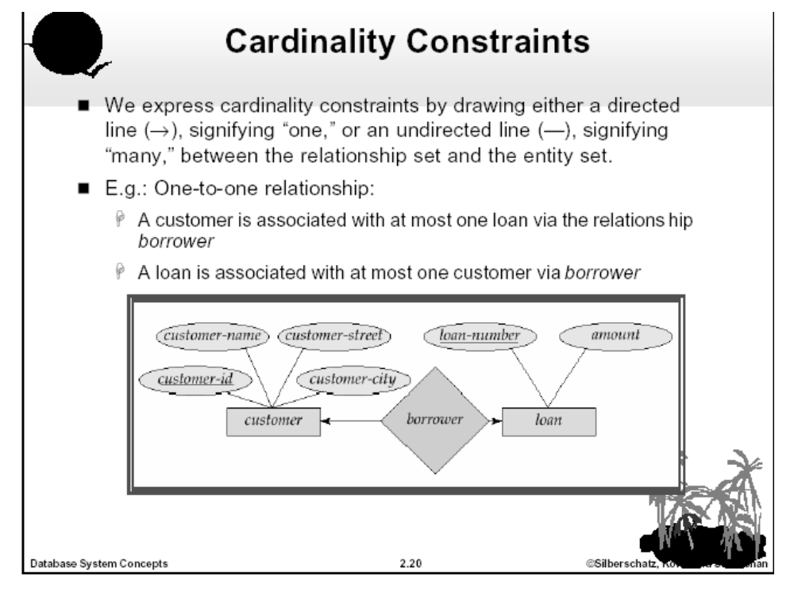
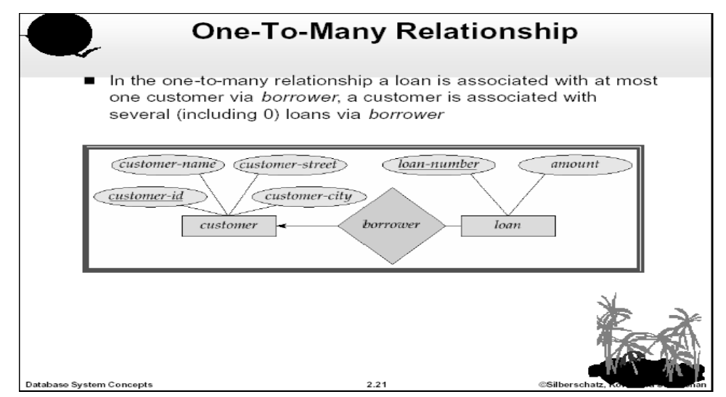
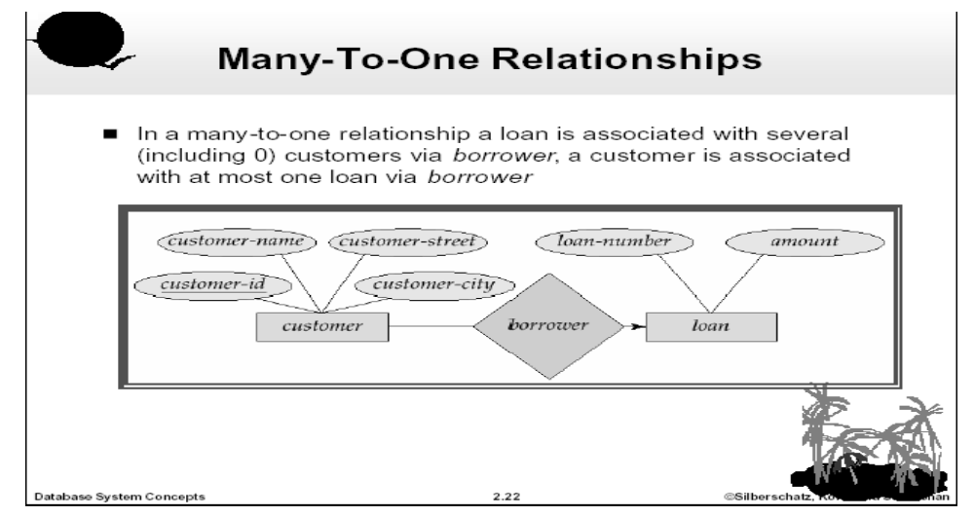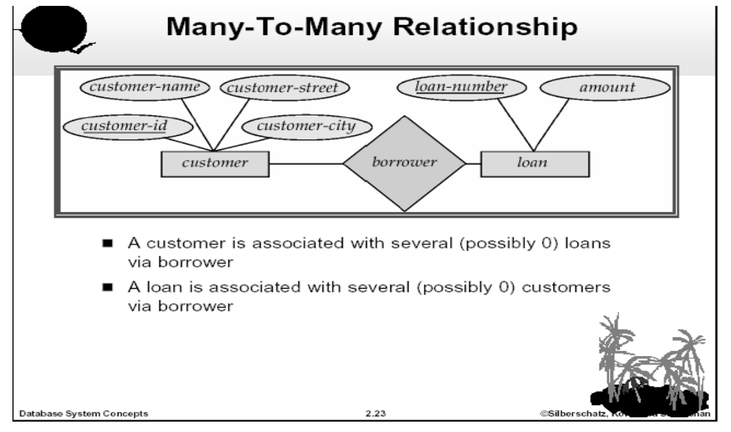

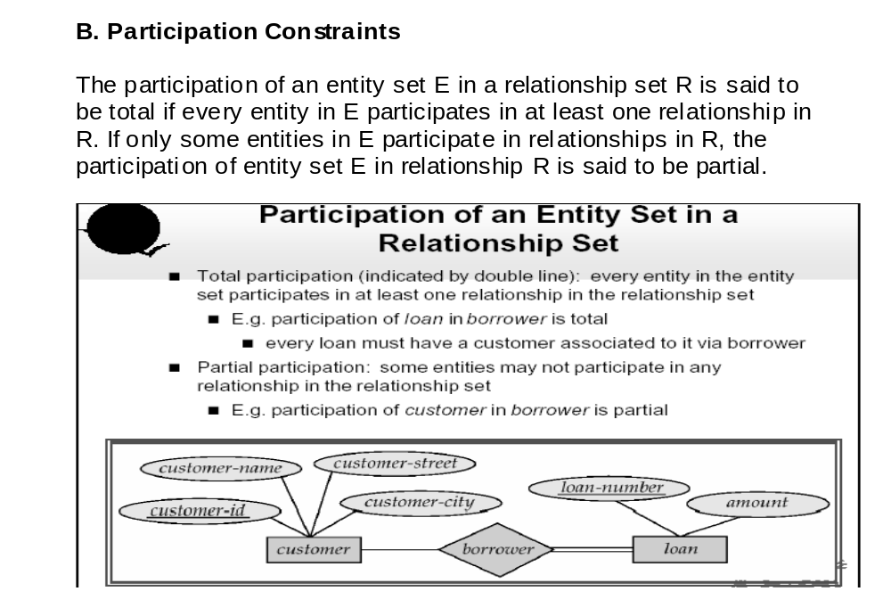

Keys:
1. Superkey – A superkey is a set of one or more attributes that, taken collectively, allow identifying uniquely an entity in the entity set. A superkey may contain extraneous attributes.
customer – {customer-id}, {customer-name, customer-id}, {all attribute}

customer-name is not a superkey
2. Candidate Key – The superkey, for which no proper subset is a superkey, is a candidate key. So the minimul superkeys are called is candidate keys.
It is possible that several distinct sets of attributes could serve as a candidate key.
{customer-name, customer-street}, {customer-id}
{customer-id, customer-name} is not a candidate key because customer-id itself is a super key/candidate key.

3. Primary Key – The primary key is to denote a candidate key that is chosen by the database designer as the principal means of identifying entities within the entity set.
A key (primary, candidate and super) is the property of the entity set, rather than of the individual entities.
So, Primary key(E-71) ⊆ Candidate Key(CSE) ⊆ Super key(DIU)

Weak Entity Sets and Strong Entity Sets
Strong Entity Set: An entity set that has a primary key is termed as strong entity set.
Weak Entity Set: An entity set may not have sufficient attributes to form a primary key. Such an entity set is termed as weak entity set.
Payment = (payment-number, payment-date, payment-amount)
Discriminator: The discriminator in the weak entity set is a set of attributes that distinguish entities in the weak entity set that depend on one particular strong entity. This is also called the partial key of the entity set.
Payment no. of weak entity set payment is the discriminator
The primary key of the identifying entity set plus the discriminator of the weak entity set forms the primary key of a weak entity set.
{loan no., payment no.} is the primary key of weak entity set

